1.15 Basic UI and Data Management

Basic Framework:
Today I officially began creating the MVP product. I broke down the overall MVP product into three parts: a points management system, a resource management system, and the linkage between the two systems. I'll start with the points management system. For this system, the MVP standard is:
- Have a data structure to store student’s data.
- Have the form for updating the points of students(add/minus).
- Have transaction record for every points modification(include time, student, delta, reason, description, operator and update the record). The event log is append-only, ensuring auditability.
- Have the ability to calculate the points of every student automatically and create a rank for teacher to reference.
I used the ChatGPT tool to write the HTML code according to my ideas and structure, and I will explain the framework and implementation of this system in the following sections.
Basic idea of the system:
This web app can be understood as a three-layer system (From the backside to frontside):
- Data layer.
This is the most essential part of the entire system and what users truly need to manage. It stores:
- A student dataset (e.g., name, ID, grade, points etc.)
- A points event log (transaction record) where each entry represents a single points change with metadata (ID, date, delta, description, operator).
The system does not treat the displayed points as the sole data source, but instead recalculates the points based on the event logs when needed (e.g., after a correction), thereby improving consistency and auditability.
- Structure layer.
The structure layer is the fixed UI skeleton built by HTML and CSS:
- Left panel: grade tabs + student search + student list.
- Right panel: selected student card + points modification form + ranking + event table
This layer defines where information appears and how the interface is organized, but it does not contain the actual dynamic data.

- Rendering layer:
The rendering layer connects the data to the UI. JavaScript:
- Filters students/events by the current grade and search keywords.
- Injects the processed result into static HTML layout.
- Keeps the UI consistent by re-rendering after every user action (e.g., submit event, correction, choose a student from the list).
Data layer:
This layer defines the system state and the audit trail. It contains two data structures:
- Student dataset (students)
Stores the current snapshot of each student:

Field | Type | Example | Meaning
id | string | “1001” | Unique student identifier
grade | string | “G1” | Grade of this student
class | string | “G1-1” | Class of this student
name | string | “Alex Wang” | Name of this student
points | int | 7 | Points of this student

Purpose: provides fast access for listing students and displaying the current score.
- Points event log (events)
Records every points change as an immutable transaction:

Field | Type | Example | Meaning
event_id | string | “f47ac10b-58cc-4372-a567-0e02b2c3d479” | Unique event identifier
time | string | “2026-01-19…” | Time stamp
student_id | string | “2002” | Modified student ID
delta | int | +3 | Delta points of this event
type | string | “课堂表现” | Reason for this event
description | string | “Answer question actively” | Additional information for this event
operator | string | “TeacherA” | The operator of this event

Purpose: preserves a complete history for transparency and accountability.
To avoid drift or corruption, the system can rebuild all students’ points from the event log by summing delta per student_id. (implemented in rebuildPointsFromEvents), ensuring the displayed scores always match the recorded history. In this MVP, both datasets are stored as JavaScript arrays. In later updates, these arrays can be replaced by a spreadsheet/database interface while keeping the same data model.

Structure Layer:
This layer provides the static UI skeleton of the web app. It defines where information appears, while rendering layer decides what content is displayed. The skeleton has left and right panel (As shown in Fig. R1).

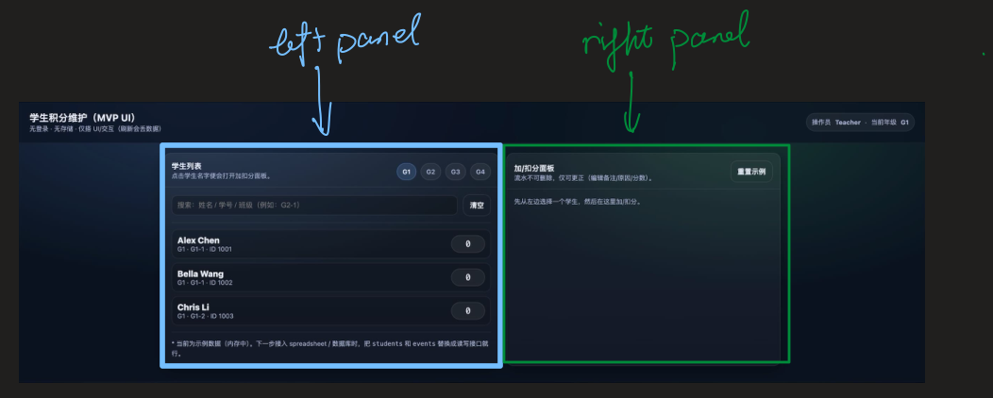
Figure R1. Overall UI Layout (left panel: navigation; right panel: operations)

Left panel | Right panel
Static components:  - Search box (filter student by keyword)  - Switch grade button (filter student by grade)  - Student list container (list of student after filtering) | Static components:  - Selected student card (name/class/id/points…)  - Points modification form (delta, reason…)  - Points ranking container  - Points event history table

Specific entries and information in the container belong to the rendering layer while the structure and template belong to structure layer (As shown in Fig. R2).
Linkage: Clicking on a specific student entry on the left panel will re-render the content of the panel on the right.

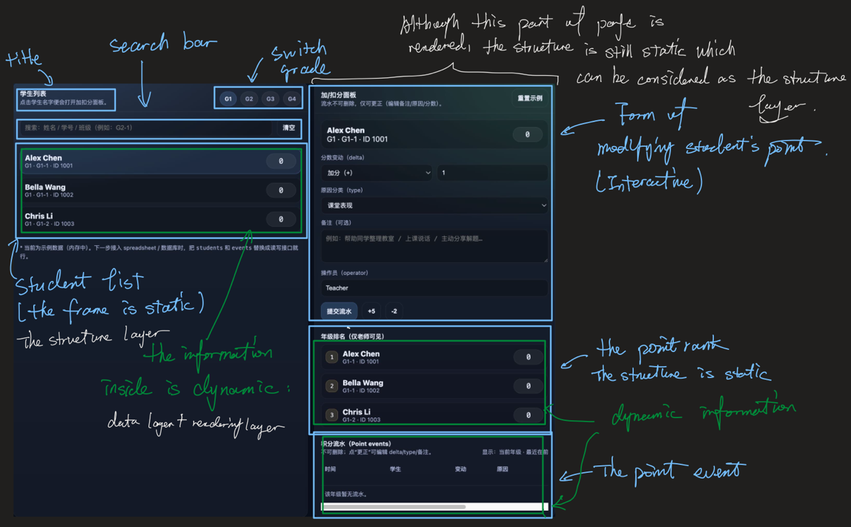
Figure R2. The Structure of UI Skeleton (blue: structure layer; green: rendering layer)

Rendering layer:
The rendering layer acts like the bridge for the data layer and the UI skeleton. The rendering layer is responsible for displaying specific information on the webpage. It embeds this information from data layer into static framework provided by the structure layer.
Whenever the user performs an action, the system updates state/data first, then triggers a re-render:
User action $→$ state/data update $→$ renderAll() $→$ UI refresh
There are three major functions: renderTabs(), renderStudentList(), renderSelectedPanel(), and they are all controlled by a central control function renderAll().
Function | Meaning
renderAll() | Executes renderTabs(), renderStudentList(), renderSelectedPanel(). Keep the UI consistent after any state change
renderTabs() | Renders grade-selection buttons and highlights the active grade (activeGrade)
renderStudentList() | Filters the students dataset by grade and search query, then renders matching student entries.
renderSelectedPanel() | Renders the right panel, including the selected student card, point modification form, grade ranking, and filtered event history table (from students and events)

Example: submitting a point change:
- User submits the form $→$submitEvent() is triggered.
- A new event record is constructed and appended to events
- Points are updated (directly or by recomputing from the event log)
- renderAll() refreshes the student list, ranking, and event table.
“Re-render after every action” approach is simple and reliable for small-scale MVPs.
For future scaling, rendering could be optimized so only affected UI modules update instead of re-rendering everything.

1.21 Downloading and uploading data

Today, I integrated spreadsheet as a database into the points management system and implemented the functions of uploading and downloading data (Students and Events). The newly added section can be divided into two sub-modules: upload and download.
Basic idea: A spreadsheet is used as the database, and the URL of the Apps Script Web App is used as a pipeline to connect the database and the web app. The two interact through a series of agreed-upon actions.
Downloading module:
All data downloads are done during the program's initialization phase:
renderall() $→$ Download data from database $→$ re-render the UI
The program sends two requests to the database via fetch() to retrieve student information and points event (action=students/events). The spreadsheet receives the request and responds according to the action: returning all content from the student and event tabs in the spreadsheet (As shown in Fig. R1).
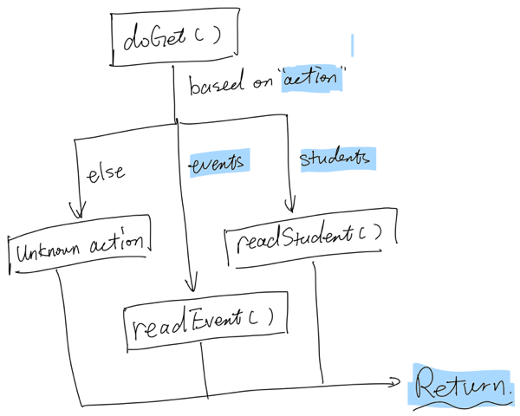

Figure R1. The splitting structure of doGet()

After receiving the content returned by the spreadsheet, the program organizes it into students and events arrays. Then, it recalculates the student scores based on the events array and re-renders the entire web app.
Uploading module:
The uploading module can be divided into two sub-parts: appendEvent() and updateEvent(). The principle is similar: send request to the spreadsheet, and in doPost(), distribute the operation based on the action (As shown in Fig.R2).
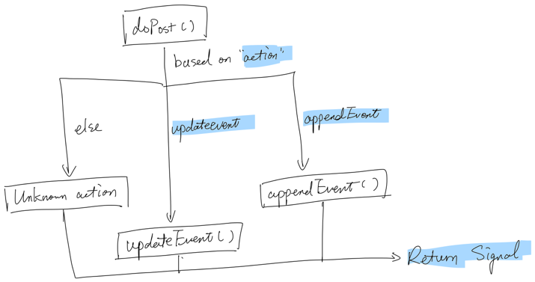

Figure R2. The splitting structure of doPost()

appendEvent()
This part is triggered at the end of submitEvent(). It uses fetch() to send a package to the spreadsheet containing action = appendEvent, and the newly assembled point event. Once the spreadsheet receives this, it will append it directly to the event tab.
updateEvent()
This part is triggered after the points event is modified (openEditPrompt()). A package is sent to the spreadsheet containing the action = updateEvent and information about the point event that was modified. After receiving this, the spreadsheet will iterate through all events, find the corresponding event based on the event_id, and update the information.
Compared to other method:
This approach, which uses a spreadsheet as a database, has its own advantages and disadvantages compared to other approaches:
Approaches | Description | Strengths | Limitations
Approach A | Google Sheets  Apps Script Web App (HTTP API) | - Quick to learn, low cost, and simple deployment  - Highly auditable (very friendly to school scenarios)  - Friendly for non-engineering personnel | - Performance and scalability  - security issues  - low constraints require self-maintenance of format.
Approach B | Firebase  Firebase Auth | - A true cloud database, offering significantly better scalability and performance than Sheets.  - It comes with a built-in user system and security rules. Frontend integration is very mature (JS SDK).  - It has high learning value as a "legitimate cloud database". | - I need to learn document models/query methods/permission rules.  - For complex transactions or auditing/login consistency, a more rigorous design is required

I choose to use this approach because it is more suitable for MVP. For future further development, I could change the database from spreadsheet to Firebase.

1.24 Goods Manage System UI and Database

After completing the first part of the development (the points monitoring system), I began the second part: the goods manage system. The overall approach was the same as the previous system. The UI still used a three-layer structure of data, structure, and rendering, while the database was still implemented using spreadsheets and API interfaces.
For this system, the MVP standard is:
- Users can add new goods: add name, quantity, price, image link, and description of it.
- Users can modify these fields of the added products.
- Users can use the search box to quickly find a product.
- All the data is connected to a single database, and all operations modify the contents of this database in real time.
I used ChatGPT as a tool to quickly convert my ideas into HTML code. I will introduce the overall structure later (the underlying concept is not significantly different from the previous system).
Basic structure of web app
This web app can be understood as a three-layer system:
Data layer:
In this system, there is only one data structure (items) for storing product information. It stores these fields:
Fields | Types | Example | Meaning
item_id | string | “I_20260123_alf2” | Unique good identifier
name | string | “Pencil” | Name
price | int | 20 | Price
qty | int | 12 | Remaining quantity
img_url | string | “https://images.unsplash.com/photo-1524995997946-a1c2e315a42f?auto=format&fit=crop&w=1200&q=60” | Image URL
note | string | “HB” | description
updated_at | string | “2026-01-28T00:59:03.256Z” | Last update time

This array stores information about all the goods. The fetch() method will be used later to send a request to the spreadsheet to populate this array.
Structure layer:
The UI structure of the entire web app can be divided into two parts: upper part and lower part (As shown in Fig. R1).

Upper Part | Lower Part
The structure is fixed and does not require rendering. Static components:  - Title and subtitle  - Search box  - Filter (based on name, price and quantity)  - Quick statistics  - Rules | Consists of cards representing goods. These cards are rendered, and their structure is fixed. Static components of each card:  - Information (name, image, price, quantity, id, and description)  - Editing button  - Buttons for quickly increasing or decreasing the quantity

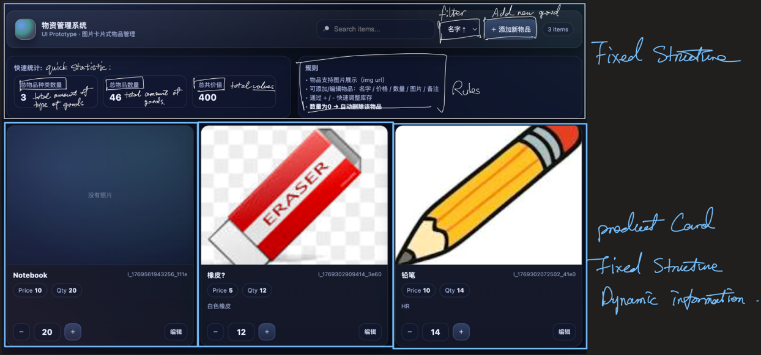
Figure R1. The Structure of UI Skeleton
The UI structure of the entire web app can be divided into two parts: upper part and lower part (As shown in Fig. R1).
In addition to the overall structure, this page also includes two forms for creating/modifying good’s information, which can be expanded using the Add New Item and Edit buttons (As shown in Fig. R2 and Fig. R3).

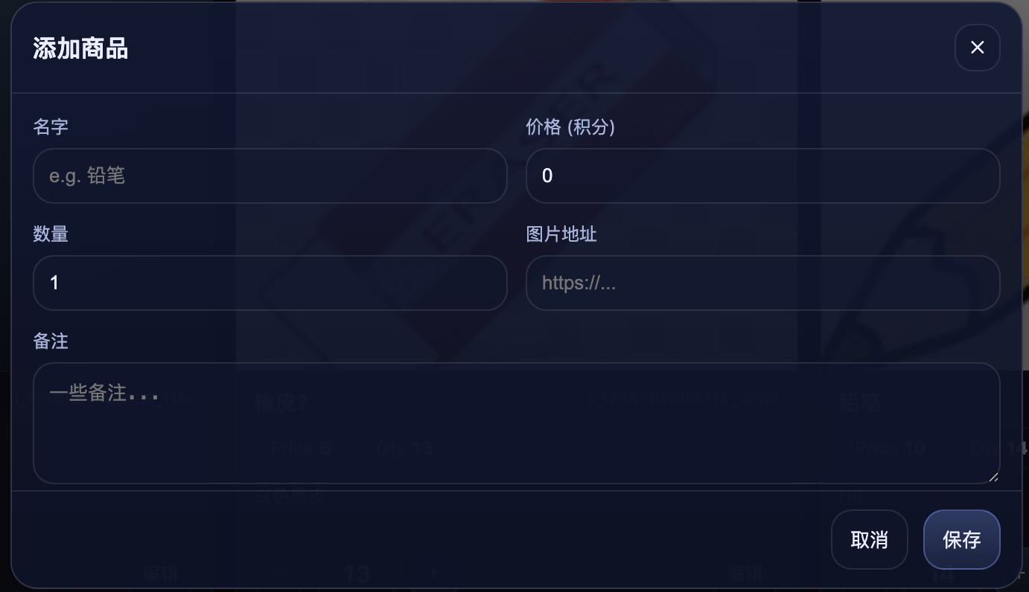
Figure R2. Form of adding a new item
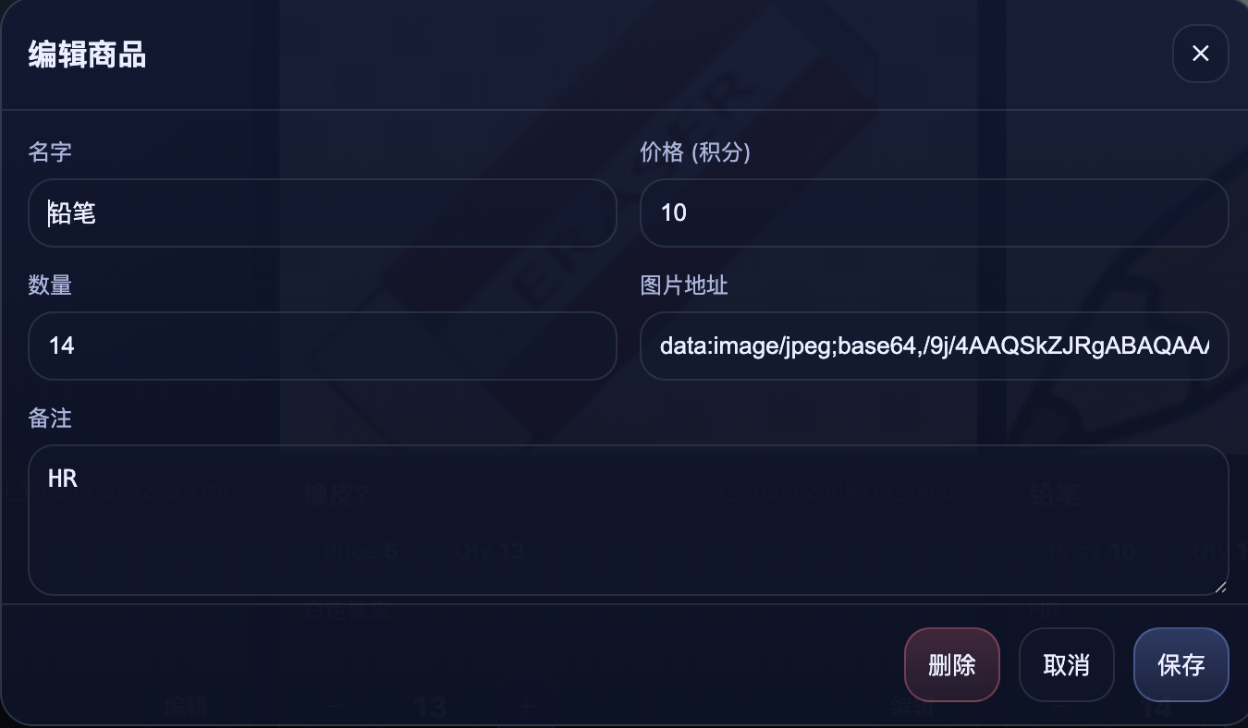
Figure R3. Form of editing information of a good

Rendering layer:
This layer uses the same pipeline approach as the rendering layer of the points monitoring system. This time, there’s only one function for this layer.
User action $→$ state/data update $→$ render() $→$ UI refresh
The entire render() method consists of three steps:
- filtering and determining the data to be rendered (filter by search key words and filter fields)
- embedding the data into the card structure
- binding the button (increase quantity button, decrease quantity button, edit button)

Data Storage
This system still uses Google’s spreadsheet as its data base. Use fetch() method with different action to interact with the data base trough Web App API.
Downloading Part
At local program’s side, loadItems() function uses fetch() with action=items to send a request to spreadsheet. At another side, spreadsheet receive the request in doGet() function and send back all the data in the spreadsheet.
Uploading Part
At local program’s side, postAction() is responsible for this part. It uses three different actions (updateItem, deleteItem, addItem) to distinguish different operations. It uses fetch() to send a request with specific data to data base.
At another side, data base will distribute requests based on action.
For action = addItem, data base will break down the data sent in the request and assemble it into a piece of good data, then push it into the spreadsheet.
For action = deleteItem, data base will find that good based on item_id and delete that row.
For action = updateItem, data base will find the good based on item_id first and extract data from the request and overwrite the original data with the new data. If the quantity of new data is 0, then delete this item.

1.27 Dual System Linkage

For the final product of MVP, I started to develop the purchasing part. The purchase of goods in the store involves both the point monitoring system and the good management system, forming a dual-system linkage. For this part, MVP standard is:
- User can view information such as the good’s name, quantity, price, description, and images.
- There is a shopping cart to record the purchased items and the total price.
- User can add goods to shopping cart.
- Select the buyer and operator to complete a checkout. Deduct the student's points, record the points transaction history, and update the inventory.
Also, two key practical constraints were considered when designing the structure:
- Students' points will only be modified during non-purchasing times such as class time, preventing situations where points are updated while purchases are being made.
- The school currently has only one operator, so there is no need to worry about multi-threaded operations causing the product quantity to become negative.
This part was added to the good management system's file. Using two different tabs to quickly switch between good management and purchasing better meets real-world needs. Similarly, a three-tier structure of data layer-structure layer-rendering layer is used.

Tab switching part:
Use activeTab records the current tab (inventory or shop). renderCurrent() function renders different tab based on activeTab. When user clicks tab button, title, subtitle, selected state as well as activeTab will change.
Data layer:
All goods information comes from items. This information is shared with the good management system and will not be described further in this log.
The cart array contains the item_id and corresponding quantities in the shopping cart. When modifying a cart, the corresponding good is found by iterating through its ID and then modified its quantity (e.g., changing quantity, adding quantity). A restriction is added here: the quantity of an item in the shopping cart can only be less than or equal to the quantity in the data base.
Structure layer:
The structure of this page can be divided into three parts: goods card, shopping cart as well as checkout section (As shown in Fig.R1). The format and principle of goods card are exactly the same as those of goods management system, so I won’t go into details here.

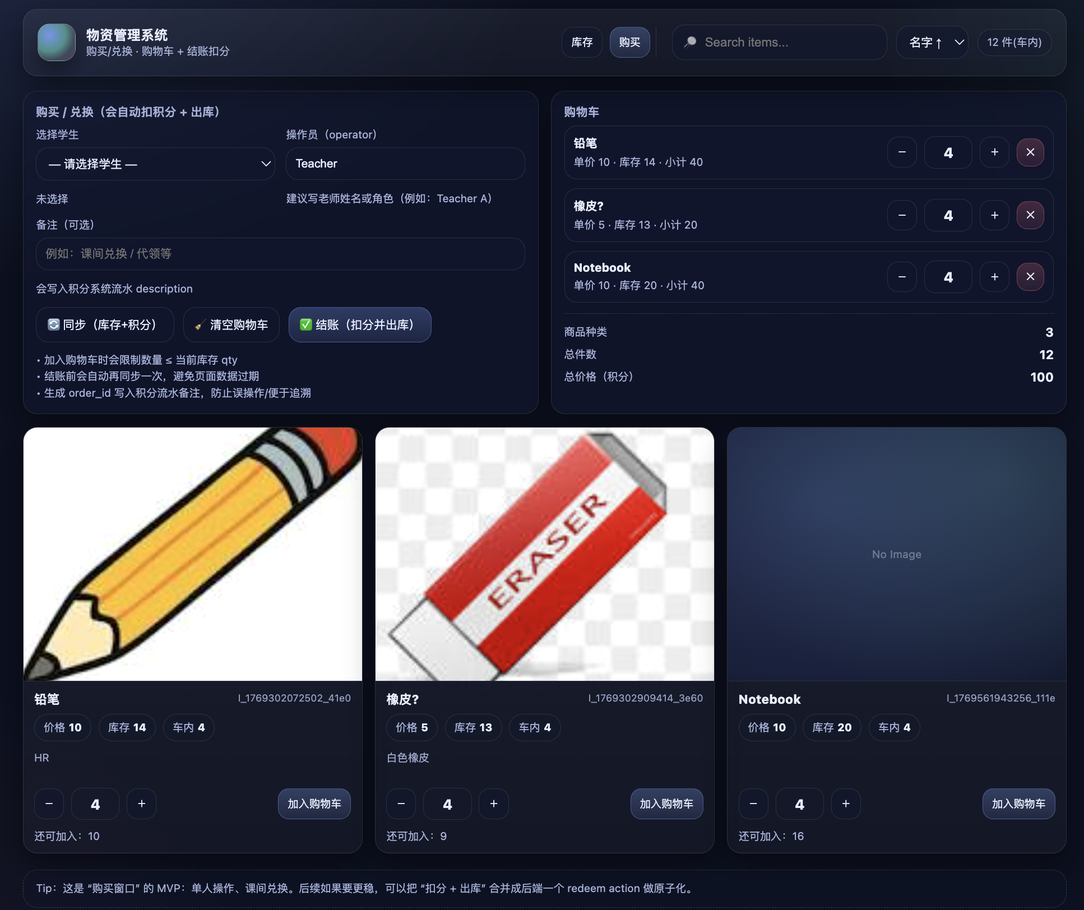
Fig.R1. The structure of shopping page

The shopping cart section is quite similar as the goods card, recording the types of items purchased and brief information. Its structure belongs to this layer, while the actual good cards in the shopping cart are rendered.
The checkout area is primarily used for operators to input information that generates points records (student name, operator, description). This area also includes commonly used buttons (synchronize inventory and student points, clear shopping cart).
Rendering layer:
When rendering the entire page, the main things to pay attention to are the goods card and shopping cart. The rendering of the goods card is the same as the previous system. The principle behind rendering a shopping cart is similar. It iterates through all [item_id, qty] pairs in the cart, and then retrieves the quantity, price, and other information of each item from the items using each item_id. Finally, it embeds fixed card templates and renders them one by one. Finally, bind the button and trigger functions.
Checkout:
The logic of the entire page is similar to that of the good management system. However, the checkout process requires additional explanation. The entire checkout process can be divided into four steps.
Step one: check the cart. First, freeze the entire page and display a waiting message box. Then, check the student's points and whether the items in the shopping cart meet the requirements (e.g., insufficient points, incorrect prices).
Step two: deduct student points. The data is combined into a point log. It is then uploaded to the database using the appendPointEvent() method.
Step three: each item in cart was taken out of the database one by one. Iterate through all item_id in the cart, deduct the quantity of each item (existing quantity - purchased quantity), and upload the newly calculated quantity to the database via postAction() with action = updateItem.
Step four: reset. Clear the cart, reset the information, and a checkout success message will pop up and the entire page will be unfrozen.
Checkout is achieved by sending multiple request messages to the database. The advantage of this approach is its ease of implementation and straightforward principle. The disadvantages are its long processing time and lack of stability (manual intervention is required if some requests time out).
In future development, I can consider combining items in the cart into a single composite message, transmitting it to the database via a single postAction(), and then disassembling and updating it in the database.

